

Receptionist

candidate Brief

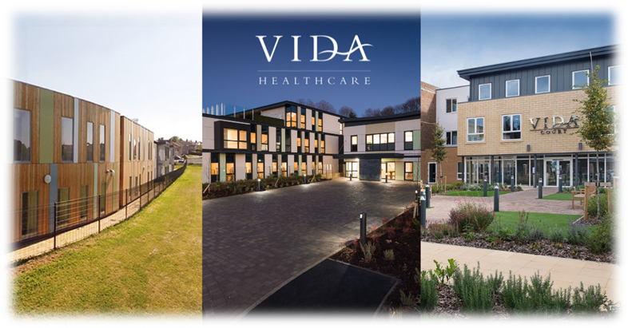

mission statement
To offer ‘Peace of Mind through Trust and Understanding for All’
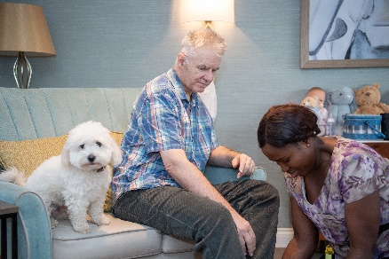

vida healthcare
Committed to providing the highest quality care for people living with dementia.
Vida Healthcare is a specialist dementia care provider based in Harrogate, North Yorkshire. Our three purpose-built care homes – Vida Hall in Starbeck, Vida Grange in Pannal and Vida Court in Harlow Carr all offer quality, person-centred care, state-of-the-art facilities and all the comforts of home.

OUR ETHOS OF CARE
We are committed to providing quality care
Every person receiving our service will experience quality care. It is essential to us that excellence remains at the forefront of our efforts.
We will use the most up to date information available to us
We will use the latest research, emerging evidence and professional literature, in conjunction with our own in-house clinical expertise to provide the highest standards of care.
We will always respect and protect the rights of our service users and deliver high quality, compassionate care
Through a comprehensive induction and ongoing training programme, our staff will have a clear understanding and respect for the core values which underpin the care and support we provide; respect, dignity, fairness, equality and autonomy.
We will approach our duties within Vida Hall, Vida Grange and Vida Court with sensitivity and respect
We will aim to adapt our ways of working whenever possible to cater for people’s needs and routines. We will respect our residents’ privacy and involve them in decisions which affect day to day living within the home.
We believe the employees of Vida Healthcare are its greatest asset
Vida Healthcare supports its staff to meet their personal responsibilities in relation to the knowledge and accountability for their own practice. We are committed to providing ongoing staff supervision and appraisals, structured training programmes and individual training objectives to allow for professional growth and development.


Job Description

Receptionist

Reports to: Home Administrator

Job Summary

As reception is ‘front of house’ for Vida Court, the Receptionist will be the first point of contact for visitors and residents and will ensure a courteous and professional welcome is delivered at all times. The Receptionist will also provide administrative support to ensure the smooth day-to-day running of the home.

Person Specification

Professional Requirements and Experience

- Educated to at least GCSE or equivalent (English & Maths are essential)
- Previous experience in a receptionist or administrative role (experience in a care home or healthcare setting is desirable)

Knowledge and Expertise

- Exemplary communication and interpersonal skills are essential
- Excellent administration and organisation skills
- Capable of prioritising a busy and varied workload
- Flexible, can-do attitude
- IT competent; MS Office, databases and email essential
- Understanding of data protection and GDPR

Responsibilities

- Welcome residents, visitors, and staff in a courteous and professional manner;
- Answer incoming phone calls promptly and direct them appropriately;
- Respond to general enquiries via phone, email, and in person, as appropriate;
- Maintain the reception and café areas to ensure a clean and tidy environment with a welcoming atmosphere;
- Maintain the visitors’ log and ensure signing-in/out procedures are followed;
- Provide general administrative support as required, including but not limited to:
  - Maintaining company car bookings
  - Maintaining meeting room bookings
  - Updating of the resident nominal role
  - Sorting and distribution of incoming mail
  - Production of handover documentation following admissions and discharges
- Assist with booking appointments, arranging meetings, and transportation for residents when required;

- Maintain strict confidentiality and professionalism at all times;
- Must be flexible with working hours, including weekends and holiday cover, as and when required.

General requirements

- Adhere at all times to Company Health and Safety Policies and maintain a clean, uncluttered, and safe environment for residents, members of the public, and staff.
- Adhere at all times to Company Policies relating to Conduct including Confidentiality Policy, Smoke-Free Policy, Standards of Attendance, Appearance, and Behaviour.
- Take responsibility for their own ongoing learning and development in order to maximise their potential.
- Represent Vida Healthcare to provide the highest possible standard of service to residents and members of the public, by treating all those ones comes into contact with in the course of one’s work in a pleasant, courteous and respectful manner.
- Staff at Vida Healthcare will share the Company’s values and commitment to providing the highest quality, compassionate care.
- The Receptionist, along with all other roles within the Company, carries the responsibility for safeguarding and promoting the welfare of our residents.

This job description indicates the main duties and responsibilities of the post. It is not intended as a complete list and may be subject to review periodically in light of the needs of the Company.

what we offer

Hours and salary
- 20 hours per week (including weekend)
- £12.71 per hour

Membership of a workplace pension scheme (where eligible)

Salary sacrifice schemes (where eligible)

- Cycle to work
- Pension

Early Pay

Staff referral scheme

Employee Assistance Programme
- A free, confidential health and wellbeing service for all of our employees and their immediate families

Healthcare Cash Plan

Blue Light Card
- The discount service for the emergency services, NHS, social care sector and armed forces, providing members with thousands of amazing discounts online and on the high street

Free on-site parking

Excellent working conditions and environment

Free access to Vida Academy
- We support all our staff, from new starters right through to senior managers, to learn and develop in their role. Vida Academy promotes lifelong learning across the organisation and establishes our staff as dementia ambassadors

how to apply

All candidates must complete our application form, including a personal statement outlining how they meet the requirements for the role.

To provide false information is an offence and may result in your application being rejected, any offer of employment being withdrawn, or summary dismissal if already appointed.

Selection for interview will be undertaken by a panel. Each panel member will assess which candidates most closely meet the necessary experience and skills criteria for the role. At least one member of the interview panel will hold a current Safer Recruitment Certificate.

Closing date for applications is Wednesday 27th May 2026.

Candidates must have the right to work in the UK, as we cannot offer sponsorship for this role
We reserve the right to close the vacancy if a suitable candidate is identified during the recruitment process.



We look forward to receiving your application.

