

wellbeing Facilitator

candidate Brief

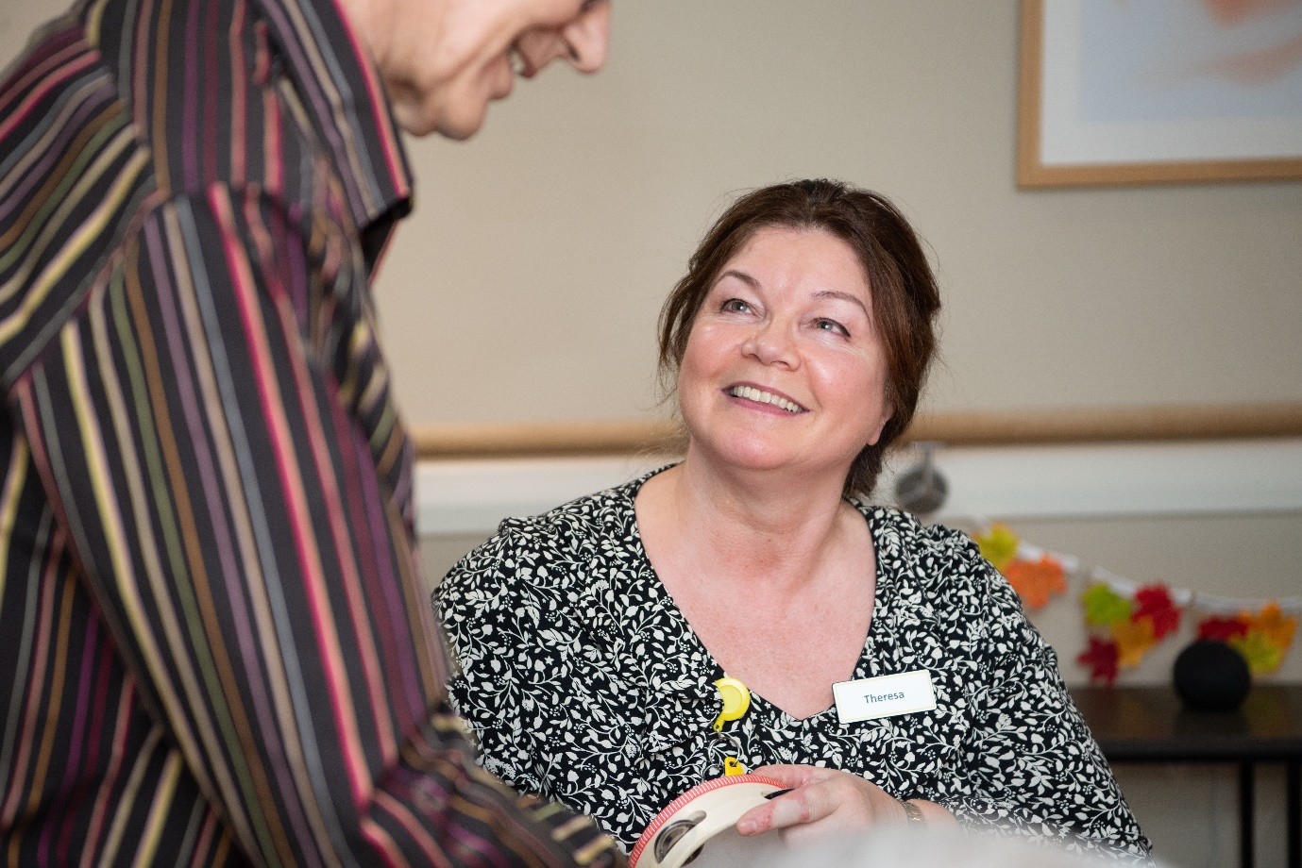

mission statement
To offer ‘Peace of Mind through Trust and Understanding for All’
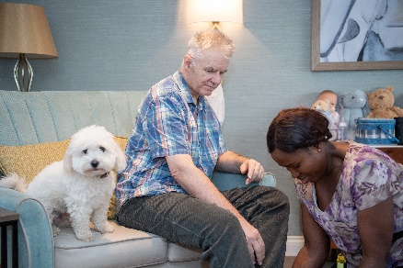

vida healthcare
Committed to providing the highest quality care for people living with dementia.
Vida Healthcare is a specialist dementia care provider based in Harrogate, North Yorkshire. Our three purpose-built care homes – Vida Hall in Starbeck, Vida Grange in Pannal and Vida Court in Harlow Carr all offer quality, person-centred care, state-of-the-art facilities and all the comforts of home.

OUR ETHOS OF CARE
We are committed to providing quality care
Every person receiving our service will experience quality care. It is essential to us that excellence remains at the forefront of our efforts.
We will use the most up to date information available to us
We will use the latest research, emerging evidence and professional literature, in conjunction with our own in-house clinical expertise to provide the highest standards of care.
We will always respect and protect the rights of our service users and deliver high quality, compassionate care
Through a comprehensive induction and ongoing training programme, our staff will have a clear understanding and respect for the core values which underpin the care and support we provide; respect, dignity, fairness, equality and autonomy.
We will approach our duties within Vida Hall, Vida Grange and Vida Court with sensitivity and respect
We will aim to adapt our ways of working whenever possible to cater for people’s needs and routines. We will respect our residents’ privacy and involve them in decisions which affect day to day living within the home.
We believe the employees of Vida Healthcare are its greatest asset
Vida Healthcare supports its staff to meet their personal responsibilities in relation to the knowledge and accountability for their own practice. We are committed to providing ongoing staff supervision and appraisals, structured training programmes and individual training objectives to allow for professional growth and development.


Job Description

Job Summary

- To work as part of the Wellbeing Team and be responsible for planning, organising and delivering varied opportunities for activity and engagement that are well researched, motivating, entertaining and add value to the lives of the residents striving all the time to create opportunities to increase wellbeing.
- To implement the principles of personal life story to create an individualised approach to the day-to-day activities to motivate and engage the wider Vida team to be part of this vital area of work
- To offer opportunities for residents to engage in activities that reflect their personal life story and cultural interests by fostering a positive and inclusive atmosphere

Principle Responsibilities

- Spend quality time with residents to develop meaningful relationships that build trust and confidence
- Support, research and collate resident’s interests and preferences in association with other care staff particularly key workers
- Support residents to develop life history books and other creative ways to aid recall, reminiscence and communication
- Plan and organise groups and 1:1 in response to identified interests and requests
- Accompany and support residents on trips out and accessing the community
- Work with the team to share ideas and good practice, skills and talents
- Work closely with resident’s families and friends and extended Vida team in planning, organising and delivering activities
- Maintain and develop the homes ‘Information Bank’ about community and other resources that may be of use to residents in the pursuit of their interests
- Continually review and evaluate the programmes and approaches being offered to residents for the purpose of measuring quality and effectiveness
- Maintain accurate records of resident participation and progress including the requirement to complete specific assessments and record and evaluate outcomes
- Alert the care team immediately of any incidents that occur that may impact on the health status of the residents so that action can be taken promptly by the appropriate team member
- Attend and contribute to team meetings, reflective practice groups and one-to-one supervisions to support personal and professional development.

Data Protection

- The Company’s Data Protection Policy is available on the Vida Policies platform. All job roles within Vida Healthcare are required to adhere to the Company’s Data Protection Policy at all times when handling personal data in the course of executing their role responsibilities. Failure to comply with the Company’s Data Protection Policy may be dealt with under the Company’s disciplinary procedure and, in serious cases, may be treated as gross misconduct leading to summary dismissal.

General requirements

All staff at Vida Healthcare, irrespective of their role are expected to:

- Adhere at all times to all Company policies including, but not limited to, Health & Safety, Conduct, Confidentiality, Attendance, Appearance, and Behaviour;
- Take responsibility for their own ongoing learning and development in order to maximise their potential;
- Represent Vida Healthcare to provide the highest possible standard of service to residents and members of the public, by treating everyone that one comes into contact with in the course of their work in a pleasant, courteous and respectful manner;
- Strive to be inclusive and create a place where we can all be ourselves and be proud of our range of diverse backgrounds;
- Treat and respect all colleagues as equals irrespective of their role, displaying and promoting Vida’s value of “In It Together”;
- Share the Company’s values and commitment to providing the highest quality, compassionate care;
- The Wellbeing Facilitator, along with all other roles within the Company, carries the responsibility for safeguarding and promoting the welfare of our residents.

Type of role

- We can offer full-time and part-time shifts, both of which will include regular weekends

Candidates must have the right to work in the UK as we cannot offer sponsorship

what we offer

Rate of pay:
  - £12.45 per hour (rising to £12.71 per hour in April 2026)

Membership of a workplace pension scheme (where eligible)

Salary sacrifice schemes (where eligible):
- Cycle to work
- Pension

Staff referral scheme

Employee Assistance Programme
- A free, confidential health and wellbeing service for all of our employees and their immediate families

Healthcare Cash Plan

Blue Light Card
- The discount service for the emergency services, NHS, social care sector and armed forces, providing members with thousands of amazing discounts online and on the high street

Free on-site parking

Excellent working conditions and environment

Free access to Vida Academy
- We support all our staff, from new starters right through to senior managers, to learn and develop in their role. Vida Academy promotes lifelong learning across the organisation and establishes our staff as dementia ambassadors


how to apply

All candidates must complete our application form, including a personal statement outlining how they meet the requirements for the role.

To provide false information is an offence and may result in your application being rejected, any offer of employment being withdrawn, or summary dismissal if already appointed.

Selection for interview will be undertaken by a panel. Each panel member will assess which candidates most closely meet the necessary experience and skills criteria for the role. At least one member of the interview panel will hold a current Safer Recruitment Certificate.

Closing date for applications is Monday 9 March 2026 at 9am

Because of the nature of the work for which you are applying, this post is exempt from the Provisions of Section 4 (2) of the Rehabilitation of Offenders Act 1974 by virtue of the Rehabilitation of Offenders Act 1974 (Exceptions) Order 1975.

All roles are subject to safeguarding and background checks, including DBS checks and satisfactory employment references.

We reserve the right to close the vacancy if a suitable candidate is identified during the recruitment process.

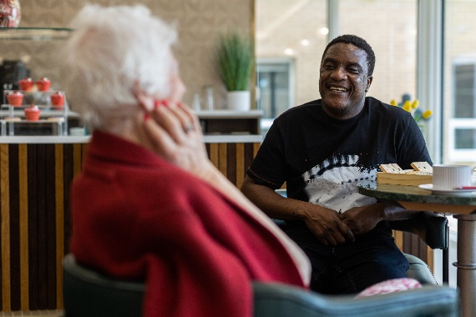

We look forward to receiving your application.

