

candidate Brief

Kitchen Assistant

Vida GRANGE

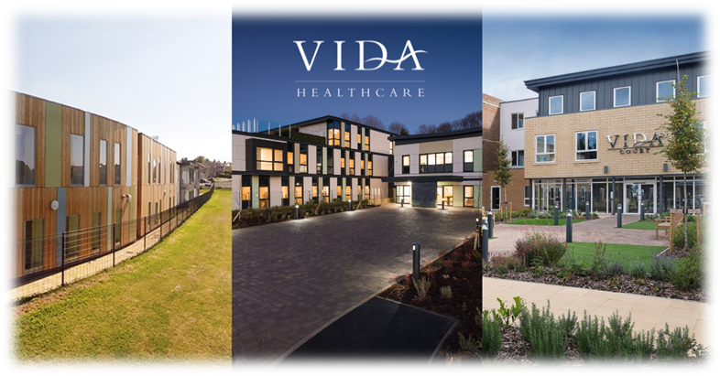

vida healthcare

Committed to providing the highest quality care for people living with dementia.

Vida Healthcare is a specialist dementia care provider based in Harrogate, North Yorkshire. Our three purpose-built care homes – Vida Hall in Starbeck, Vida Grange in Pannal and Vida Court in Harlow Carr all offer quality, person-centred care, state-of-the-art facilities and all the comforts of home.

mission statement

To offer ‘Peace of Mind through Trust and Understanding for All’

OUR ETHOS OF CARE

**We are committed to providing quality care**

Every person receiving our service will experience quality care. It is essential to us that excellence remains at the forefront of our efforts.

**We will use the most up to date information available to us**

We will use the latest research, emerging evidence and professional literature, in conjunction with our own in-house clinical expertise to provide the highest standards of care.

**We will always respect and protect the rights of our service users and deliver high quality, compassionate care**

Through a comprehensive induction and ongoing training programme, our staff will have a clear understanding and respect for the core values which underpin the care and support we provide; respect, dignity, fairness, equality and autonomy.

**We will approach our duties within Vida Hall, Vida Grange and Vida Court with sensitivity and respect**

We will aim to adapt our ways of working whenever possible to cater for people’s needs and routines. We will respect our residents’ privacy and involve them in decisions which affect day to day living within the home.

**We believe the employees of Vida Healthcare are its greatest asset**

Vida Healthcare supports its staff to meet their personal responsibilities in relation to the knowledge and accountability for their own practice. We are committed to providing ongoing staff supervision and appraisals, structured training programmes and individual training objectives to allow for professional growth and development.





Job Description

**Job Title: Kitchen Assistant**

**Reports to: Head Chef**

**Job Summary**

* To ensure a clean and orderly kitchen by thorough cleaning of equipment and facilities conforming to proper sanitation and infection control standards.
* To support the Head Chef and Assistant Cook in the effective operation of the kitchen.

**Professional requirements and experience**

* Educated to at least GCSE or equivalent (English & Maths are essential)
* A proven track record of preparing and cooking meals using fresh ingredients in a commercial environment
* A formal cookery/chef/catering qualification or at least two years’ experience
* Previous experience of working within a Care Home setting would be advantageous

**Knowledge and Expertise**

* Exemplary administration and organisation skills essential
* Excellent inter-personal skills
* Good listening and communication skills
* Capable of prioritising a busy and varied workload
* Flexible, can-do attitude

**Responsibilities**

* Prepare nutritional food to a high standard, taking into account any dietary requirements
* Be involved in the serving of meals
* Ensure the highest standards of hygiene are maintained
* Supervision/direction of Kitchen Assistants
* Meet all statutory requirements to address food hygiene regulations including holding a suitable food hygiene certificate (training will be provided)
* Perform any other such reasonable duties as maybe required



what we offer

Excellent salary

Membership of a workplace pension scheme (where eligible)

Salary sacrifice schemes (where eligible):

* Cycle to work
* Pension

Employee Assistance Programme

* A free, confidential health and wellbeing service for all of our employees and their immediate families

Healthcare Cash Plan

Blue Light Card

* The discount service for the emergency services, NHS, social care sector and armed forces, providing members with thousands of amazing discounts online and on the high street

Free on-site parking

Excellent working conditions and environment

Free access to Vida Academy

* Vida Academy is the way we support all our staff, from new starters right through to senior managers, to learn and develop in their role. Vida Academy promotes lifelong learning across the organisation and establishes our staff as dementia ambassadors





how to apply

All candidates must complete our [application form](https://vidahealthcare.co.uk/wp-content/uploads/2024/03/Application-for-Employment.docx), including a personal statement outlining how they meet the requirements for the role.

To provide false information is an offence and may result in your application being rejected, any offer of employment being withdrawn, or summary dismissal if already appointed.

Selection for interview will be undertaken by a panel. Each panel member will assess which candidates most closely meet the necessary experience and skills criteria for the role. At least one member of the interview panel will hold a current Safer Recruitment Certificate.

Closing date for applications is **12 January 2025**

Interviews will be held week commencing **20 January 2025**

We reserve the right to close the vacancy if a suitable candidate is identified during the recruitment process.



We look forward to receiving your application.

