

Care assistant

candidate Brief

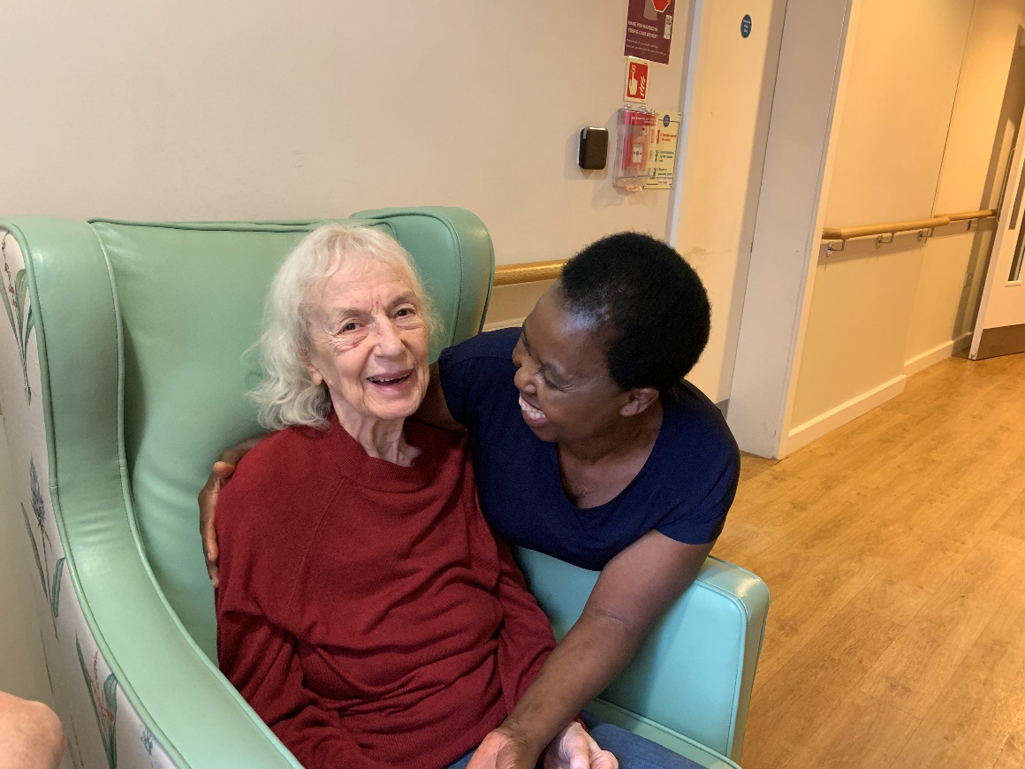

mission statement

To offer ‘Peace of Mind through Trust and Understanding for All’

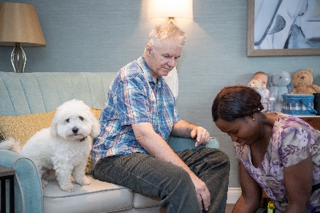

vida healthcare

Committed to providing the highest quality care for people living with dementia.

Vida Healthcare is a specialist dementia care provider based in Harrogate, North Yorkshire. Our three purpose-built care homes – Vida Hall in Starbeck, Vida Grange in Pannal and Vida Court in Harlow Carr all offer quality, person-centred care, state-of-the-art facilities and all the comforts of home.

OUR ETHOS OF CARE

**We are committed to providing quality care**

Every person receiving our service will experience quality care. It is essential to us that excellence remains at the forefront of our efforts.

**We will use the most up to date information available to us**

We will use the latest research, emerging evidence and professional literature, in conjunction with our own in-house clinical expertise to provide the highest standards of care.

**We will always respect and protect the rights of our service users and deliver high quality, compassionate care**

Through a comprehensive induction and ongoing training programme, our staff will have a clear understanding and respect for the core values which underpin the care and support we provide; respect, dignity, fairness, equality and autonomy.

**We will approach our duties within Vida Hall, Vida Grange and Vida Court with sensitivity and respect**

We will aim to adapt our ways of working whenever possible to cater for people’s needs and routines. We will respect our residents’ privacy and involve them in decisions which affect day to day living within the home.

**We believe the employees of Vida Healthcare are its greatest asset**

Vida Healthcare supports its staff to meet their personal responsibilities in relation to the knowledge and accountability for their own practice. We are committed to providing ongoing staff supervision and appraisals, structured training programmes and individual training objectives to allow for professional growth and development.



Job Description

**Job Title: Care Assistant**

**Reports to: Nurse/Team Leader/Senior Care Assistant**

**Job Summary**

* To provide quality care to people living with dementia, ensuring our core values of respect, dignity, fairness, equality and autonomy are met at all times
* To share with other staff in meeting the personal care needs of residents in a way that respects the dignity of the individual and promotes independence – Enable first, care second
* To help in the care of the care users’ physical environment by supporting an enriched, stimulating and engaging home
* To assist the Activity Support Team with gathering life story information on all residents and creating opportunity for social activity and engagement during your daily duties
* To take delegated responsibilities from your line manager in respect to the residents under your care

**Professional requirements and experience**

* To have passion and commitment for quality dementia care and to the Vida Healthcare ‘Ethos of Care’
* Previous care experience would be advantageous
* To meet all required mandatory training requirements and other identified learning opportunities that are required to improve quality care

**Knowledge and Expertise**

* Awareness of dementia and person-centred care ensuing the person with dementia has involvement in all aspects of their wellbeing
* Strong attention to detail
* Good IT skills
* Good communication skills, particularly in English speaking
* Capable of dealing with a busy and varied workload with the ability to work on own initiative and as part of a wider team
* Flexible, can-do attitude

**Responsibilities**

* Work in a person-centred team ensuring you show respect, consideration and support to your peers and be aware of your own emotional well-being.
* Assist residents in your care with all aspects of personal care needs including dressing, undressing, bathing and toilet.
* Follow instructions as per care profile in respect to application of creams and lotions and sign all appropriate forms when complete
* Communicate any identified concerns to person in charge and record in care profile.
* Help care users with mobility problems and other physical disabilities such as incontinence; help in the care and use of aids and personal equipment (hoists/wheel chairs/zimmer frames/sensor mats/ bed rails).
* Follow risk assessments and care plan directives.
* Support residents who may experience some form of distress in relation to their dementia. This may involve carrying out physical interventions in line with Positive Intervention in Dementia Care (PIDC) training and individual resident care plans.
* Respond promptly to emergency call bells and assistance bells and alert person in charge in event of injury/assessment requirements.
* Report accidents/incidents/near misses to Person in Charge promptly and record all observations on allocated forms.
* Promote positive communication opportunities by understanding your client’s life history and building a trusting relationship.
* Assist with all aspects of nutrition including support with feeding, promoting choice, preferences and independence. Complete all nutrition charts and assessment tools as instructed by your line manager.
* Help in the promotion of mental and physical wellbeing through the use of activity and engagement opportunities that are person-centred and specific to the resident’s cognitive ability.
* Be aware of the role/responsibilities in terms of Health and Safety at Work Act, the employee Handbook and Company Policies and Procedures.
* Answer the door, the telephone meet and greet visitors to the home. Take record and transmit messages promptly to person in charge.
* Read all resident care profiles and write in appropriate daily notes/key worker notes/daily charts as instructed by your line manager
* Take part in staff and residents’ meetings and attend all mandatory/organised training, supervision and appraisals to support your professional development.
* Assist with allocated tasks involved in maintaining good infection control procedures within the home (cleaning of commodes/mattresses/medical equipment/household tasks) as per daily/weekly/monthly work schedules.
* Be aware of your own responsibilities in relation to safeguarding vulnerable adults. Follow company policy and procedures in the event of safeguarding alerts being raised. Attend all Safeguarding and other mandatory training and refresher courses.
* Follow Company policy and procedures and learn from the strong leadership and direction of your line manager
* Attend all training opportunities that will develop your knowledge and skills in supporting a person with dementia achieve quality outcomes

**Job Type**

* Day and night shifts available, typically 7:45 am to 8:00 pm and 7:45 pm to 8:00 am, but other shift patterns may be available depending on the needs of the service
* Shifts operate on a 2-week rolling rota, to include regular weekends

**Candidates must have the right to work in the UK as we cannot offer sponsorship**

what we offer

Rate of pay:

* + £13.01 per hour for day shifts
  + £13.34 per hour for night shifts

Membership of a workplace pension scheme (where eligible)

Salary sacrifice schemes (where eligible):

* Cycle to work
* Pension

Staff referral scheme

Employee Assistance Programme

* A free, confidential health and wellbeing service for all of our employees and their immediate families

Healthcare Cash Plan

Blue Light Card

* The discount service for the emergency services, NHS, social care sector and armed forces, providing members with thousands of amazing discounts online and on the high street

Free on-site parking

Excellent working conditions and environment

Free access to Vida Academy

* We support all our staff, from new starters right through to senior managers, to learn and develop in their role. Vida Academy promotes lifelong learning across the organisation and establishes our staff as dementia ambassadors



how to apply

All candidates must complete our application form, including a personal statement outlining how they meet the requirements for the role.

To provide false information is an offence and may result in your application being rejected, any offer of employment being withdrawn, or summary dismissal if already appointed.

Selection for interview will be undertaken by a panel. Each panel member will assess which candidates most closely meet the necessary experience and skills criteria for the role. At least one member of the interview panel will hold a current Safer Recruitment Certificate.

Closing date for applications is **7th October 2024**

Interviews will be held week commencing **14th October 2024**

We reserve the right to close the vacancy if a suitable candidate is identified during the recruitment process.

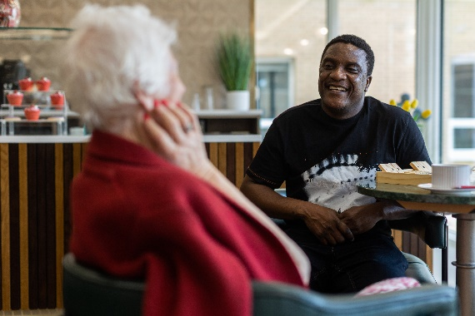

We look forward to receiving your application.